ASSINGMENT 9

Name : G.siddhartha Reddy Roll NO : 2503a52368

– Documentation Generation - Automatic documentation and code comments

Task Description :1 – Docstring , Inline comments , Google-style documentation
Task: Compare the three approaches. Discuss their advantages and disadvantages. Explain suitable use cases. Recommend the best documentation style for a mathematical utilities library

Prompt: Explain what the function does, describe the input parameter, and describe the return value. Keep the documentation simple and suitable for a beginner.

Input:
def find_max_docstring(numbers):
"""Return the maximum number from a list of numbers.""" return max(numbers)

def find_max_inline(numbers):
# Check and return the maximum value in the input list
return max(numbers) # Built-in max function handles the comparison

def find_max_google(numbers):

"""Finds the maximum value in a list of numbers.

Args:

numbers (list of int/float): A list of numerical values to search.

Returns:
int/float: The largest number in the list.

Raises:
ValueError: If the input list is empty. """
if not numbers:
raise ValueError("The list of numbers cannot be empty.") return max(numbers)
#example usage
numbers = [3, 5, 1, 8,
2]
print(find_max_docstring(numbers)) # Output: 8 print(find_max_inline(numbers)) # Output: 8 print(find_max_google(numbers)) # Output: 8

Explanation:
The purpose of this problem is to understand different ways of documenting Python code.

Output:
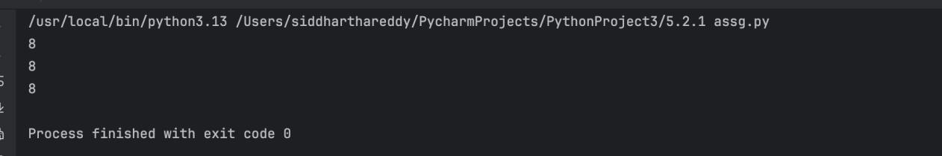

Task Description :2 – Documentation for login()
Task: Write documentation using all three formats. Critically compare the approaches. Recommend which documentation style would be most useful for new developers joining a project.

Prompt : Generate dd a clear inline comment to the following Python function. The comment should explain what the function is doing without unnecessarily explaining obvious Python syntax.
def find_max(numbers):
return max(numbers)

Input:

def login_docstring(user, password, credentials):
"""Verify if the provided password matches the stored password for the given user in the credentials registry."""
return credentials.get(user) == password

def login_inline(user, password, credentials):
# Retrieve password for user and evaluate match
# Using .get() prevents KeyError if user is missing, returning None which safely compares False
return credentials.get(user) == password

def login_google(user, password, credentials):

"""Authenticates a user against a provided credentials store.

Args:
user (str): The unique identifier/username of the user trying to log in. password (str): The plain-text security password provided by the client.
credentials (dict): A dictionary mapping usernames (str) to their corresponding correct passwords (str).

Returns:
bool: True if the user exists and the password matches; False otherwise. """
return credentials.get(user) == password #example usage
credentials = {'alice': 'password123', 'bob': 'securepass'}
print(login_docstring('alice', 'password123', credentials)) # Output: True print(login_inline('alice', 'password123', credentials)) # Output: True print(login_google('alice', 'password123', credentials)) # Output: True

Explanation:
This problem is similar to Problem 1, but the function represents a login/authentication operation.

Output:
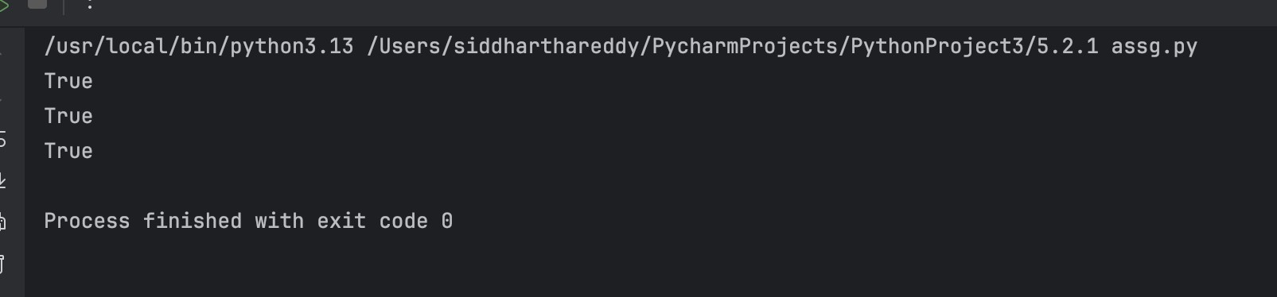

Task Description :3 – Calculator Module
Task: Display the module documentation in the terminal. Generate the
documentation as an HTML file using Python's pydoc. Open the generated HTML file in a browser and verify it
methods.

Prompt: Generate Convert the following Python function into a properly documented Google-style function. Include a description, Args section, and Returns section.
def find_max(numbers):
return max(numbers)

Input:
"""A basic calculator module providing arithmetic operations with structured documentation.
"""

def add(a, b):
"""Returns the sum of two numbers.

Args:
a (int/float): The first number.
b (int/float): The second number.

Returns:
int/float: The sum of a and
b. """
return a + b

def subtract(a, b):
"""Returns the difference of two numbers.

Args:
a (int/float): The first number (minuend).
b (int/float): The second number (subtrahend).

Returns:
int/float: The difference of a and
b. """
return a - b

def multiply(a, b):
"""Returns the product of two numbers.

Args:
a (int/float): The first factor.
b (int/float): The second factor.

Returns:
int/float: The product of a and
b. """
return a * b

def divide(a, b):

"""Returns the quotient of two numbers.

Args:
a (int/float): The dividend.
b (int/float): The divisor.

Returns:
float: The quotient of a divided by b.

Raises:
Zero DivisionError: If the divisor b is zero. """
if b == 0:
raise Zero DivisionError("Division by zero is not allowed.") return a / b
#example usage
print(divide(10, 2)) # Output: 5.0
print(multiply(3, 4)) # Output: 12
print(subtract(10, 5)) # Output: 5
print(add(7, 3)) # Output: 10

Explanation:
This problem introduces automatic documentation generation.
Instead of manually creating a documentation website,Python's pydoc can read the docstrings from your program and generate documentation.

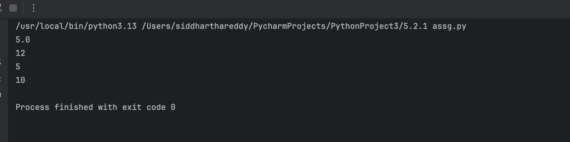
Output:

Task Description :4 – Conversion Utilities Module
Task: Use Copilot to automatically generate docstrings. Generate the
documentation in the terminal. Export the documentation to HTML. Open the HTML documentation in a browser.

Prompt: Generate Compare docstrings, inline comments, and Google-style documentation for the following Python function:
def find_max(numbers):
return max(numbers)
For each approach, explain:
- Advantages
- Disadvantages
- Suitable use cases
Finally, recommend the most effective documentation style for a mathematical utilities library and justify your answer.

Input:
"""A conversion utility module providing functions to convert numbers between decimal, binary, and hexadecimal bases.
"""

def decimal_to_binary(n):
"""Converts a decimal integer to its binary string representation.

Args:
n (int): The decimal integer to convert.

Returns:
str: The binary representation of the integer (prefixed with '0b').

Raises:
TypeError: If the input is not an integer. """
if not isinstance(n, int):
raise TypeError("Input must be an integer.") return bin(n)

def binary_to_decimal(b):
"""Converts a binary string to its decimal integer representation.

Args:
b (str): The binary string to convert (can optionally start with '0b').

Returns:
int: The decimal integer value of the binary string.

Raises:
ValueError: If the input string is not a valid binary number. TypeError: If the input is not a string.
"""

if not isinstance(b, str):
raise TypeError("Input must be a string.") return int(b, 2)

def decimal_to_hexadecimal(n):
"""Converts a decimal integer to its hexadecimal string representation.

Args:
n (int): The decimal integer to convert.

Returns:
str: The lowercase hexadecimal representation of the integer (prefixed with '0x').

Raises:
TypeError: If the input is not an integer. """
if not isinstance(n, int):
raise TypeError("Input must be an integer.") return hex(n)
#example usage
print(decimal_to_binary(10)) # Output: '0b1010' print(binary_to_decimal('0b1010')) # Output: 10 print(decimal_to_hexadecimal(255)) # Output: '0xff'

Explanation:
This problem combines programming + AI-assisted documentation + automatic documentation generation.

Output:

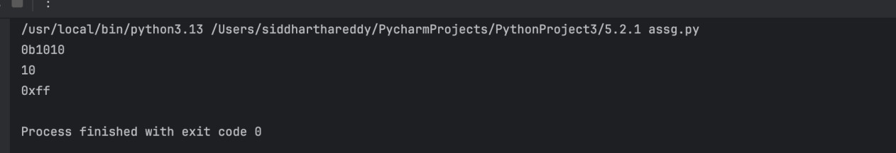

Task-5: Course Management Module
Prompt: Generate a Python module named course.py for a simple course management system.

Input:

"""A course management module providing utilities to add, remove, and retrieve course details.
"""
# In-memory database to store course information
_course_db = {}

def add_course(course_id, name, credits):
"""Adds a new course to the registry.

Args:
course_id (str): The unique identifier for the course (e.g., 'CS101'). name (str): The name of the course.
credits (int): The number of academic credits for the course.

Raises:
ValueError: If the course_id already exists in the registry.
TypeError: If credits is not an integer or if course_id/name is not a string. """
if not isinstance(course_id, str) or not isinstance(name, str): raise TypeError("course_id and name must be strings.")
if not isinstance(credits, int):
raise TypeError("credits must be an integer.") if course_id in _course_db:
raise ValueError(f"Course with ID {course_id} already exists.")

_course_db[course_id] =
{ "name": name, "credits": credits
}

def remove_course(course_id):
"""Removes an existing course from the registry.

Args:
course_id (str): The unique identifier of the course to be removed.

Raises:
KeyError: If the course_id is not found in the registry. """
if course_id not in _course_db:

raise KeyError(f"Course with ID {course_id} does not exist.") del _course_db[course_id]

def get_course(course_id):
"""Retrieves the details of a specific course.

Args:
course_id (str): The unique identifier of the course to retrieve.

Returns:
dict: A dictionary containing the course 'name' and 'credits'.

Raises:
KeyError: If the course_id is not found in the registry. """
if course_id not in _course_db:
raise KeyError(f"Course with ID {course_id} does not exist.") return _course_db[course_id]
#example usage
add_course('CS101', 'Introduction to Computer Science', 4)
print(get_course('CS101')) # Output: {'name': 'Introduction to Computer Science', 'credits': 4}

Explanation:
Review the course.py module and check whether the documentation for add_course(), remove_course(), and get_course() is complete and consistent.

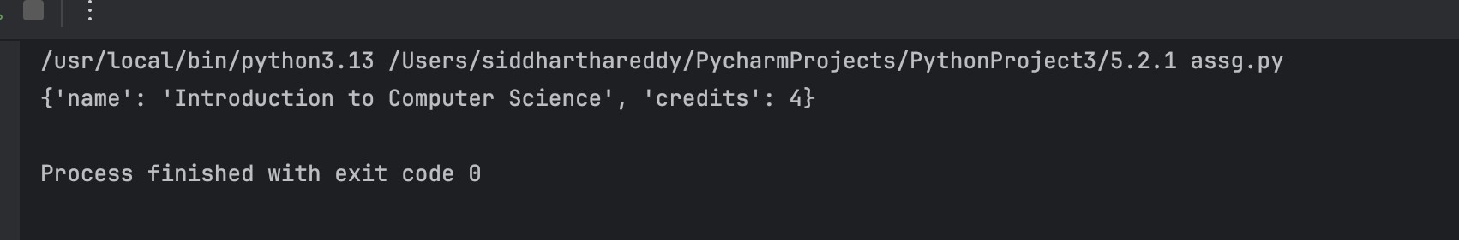
Output:

